1、视频操作指引 Video Operation Guide
https://youtube.com/shorts/lVUNDZ45xNY?feature=share

新增功能：探索 精彩“故事” New Feature: Explore Wonderful "Stories"

核心亮点：
与 AI 实时互动，剧情走向随对话动态推进​
自带刺激感剧情设计，提升用户沉浸体验​
Key features:
Real-time interaction with AI, story progression dynamically influenced by conversations
Self-contained thrilling storyline design, enhancing the user's immersive experience
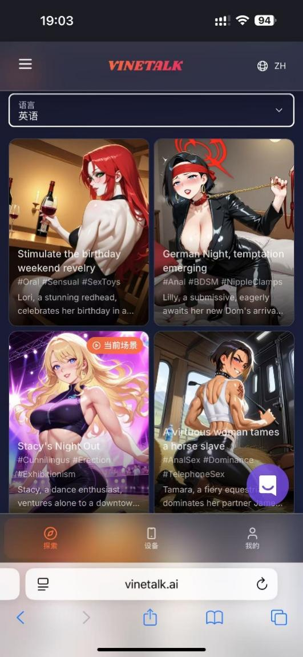

新增优化：侧边导航栏 New optimization: Side navigation bar
布局直观，用户可快速定位各功能入口
分类清晰，减少操作路径，提升使用效率
The layout is intuitive, allowing users to quickly locate each function entry.
The classification is clear, reducing the operation paths and improving the usage efficiency.
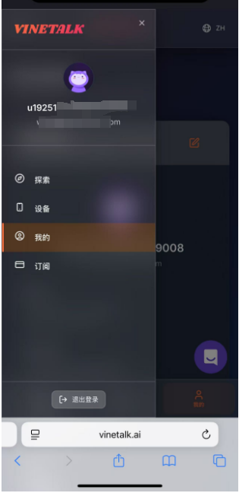

4、新增功能：游客模式 New feature: Visitor Mode
无需登录，即可查看剧情简介，通过精彩的简介内容吸引用户注册订阅。 No login is required to view the plot summary. The captivating summary content can attract users to register and subscribe.


5、剧情简介 Plot Summary

小叔的禁忌之夜
- 场景概要：深夜私密房间内的禁忌情欲故事。女主角对小叔进行极致的身心控制，通过尿道棒禁止高潮、多种道具调教等方式，将对方彻底征服。剧情充满背德刺激感，展现了复杂的权力支配关系，从温柔诱导到强势控制，情节层层递进，最终达到完全的身心臣服状态。
- 适用用户：喜欢被支配控制体验的男性用户；对禁止高潮、道具调教等BDSM元素感兴趣的用户；偏好背德禁忌情节的成年用户；享受被强势女性主导的submissive倾向用户；寻求极致身心刺激体验的高阶玩家。
- 语言：中文
- 图片：

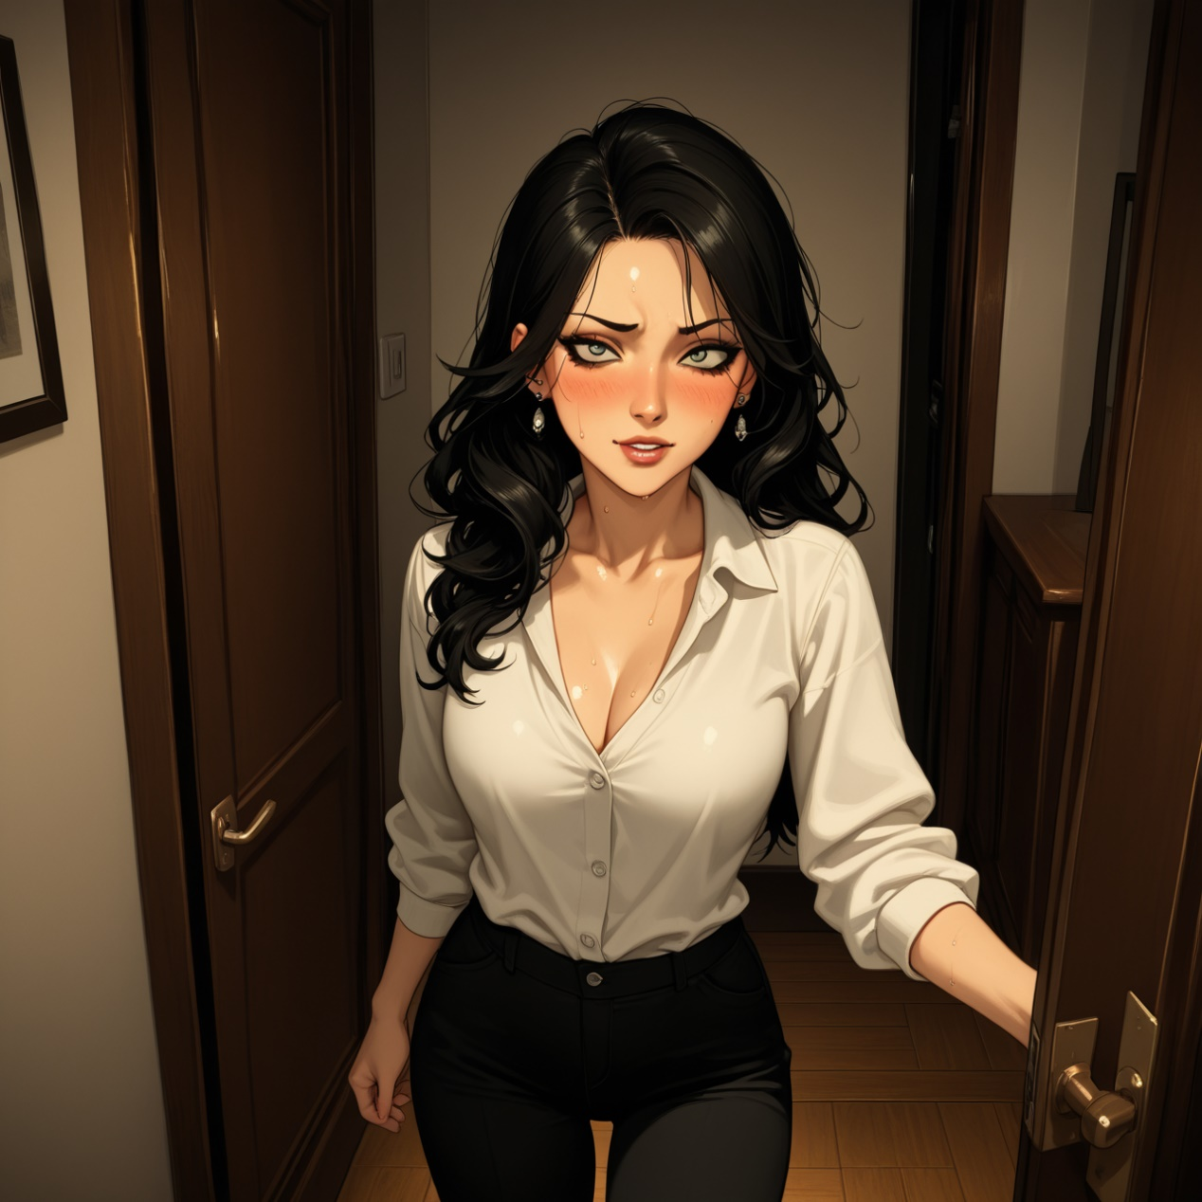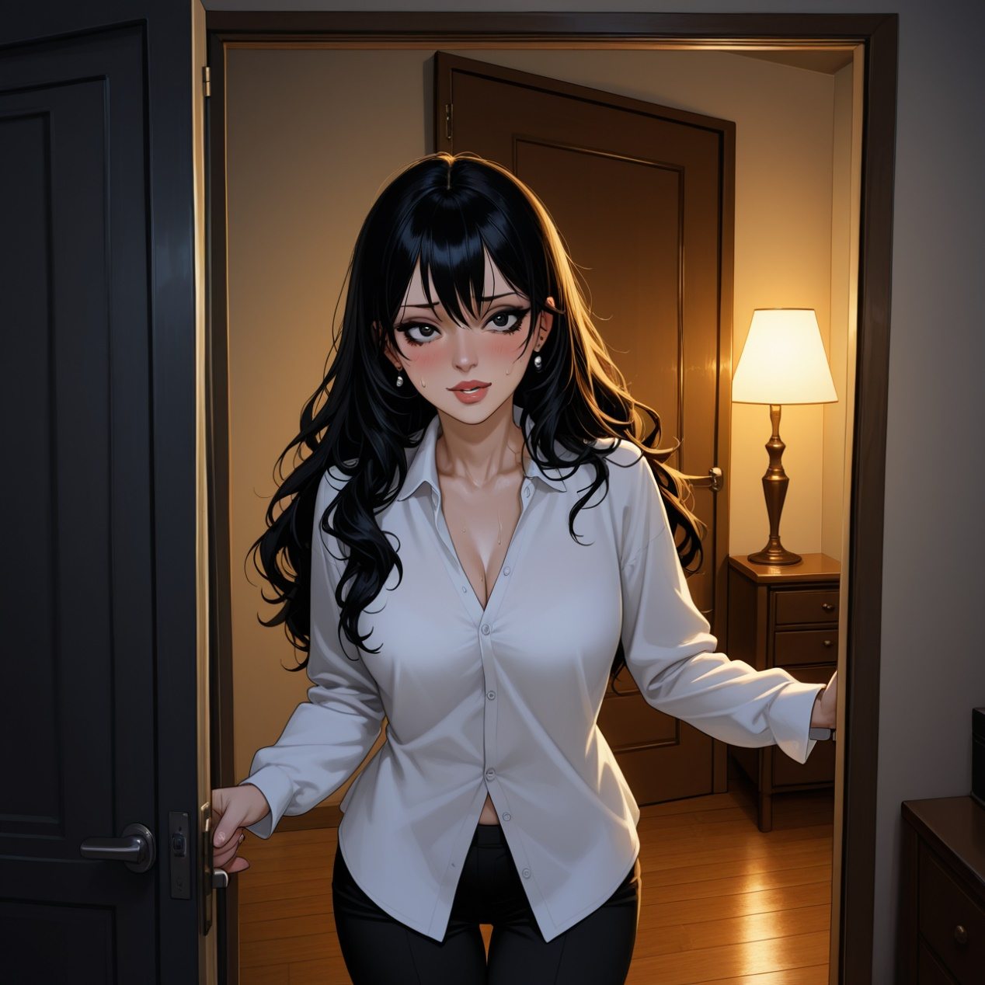

捉奸反被虐
- 场景概要：酒店房间内的复仇大戏。前夫沈穆修本想捉奸，却反被前妻反制。女主角通过一系列极端手段——束缚、耳光、红酒灌肠、皮鞭抽打、踩踏性器等，将昔日高高在上的前夫彻底征服。从最初的愤怒对峙到最终的完全屈服，展现了权力关系的彻底颠覆，背叛与报复的情感纠葛在肉体折磨中得到极致释放。
- 适用用户：喜欢被强势女性支配的男性用户；对复仇题材和权力颠覆情节感兴趣的用户；偏好极端BDSM体验（鞭打、踩踏、灌肠等）的高阶玩家；享受屈辱调教和心理征服的submissive用户；对出轨背景下的禁忌复仇故事有兴趣的成年用户。
- 语言：中文
- 图片：
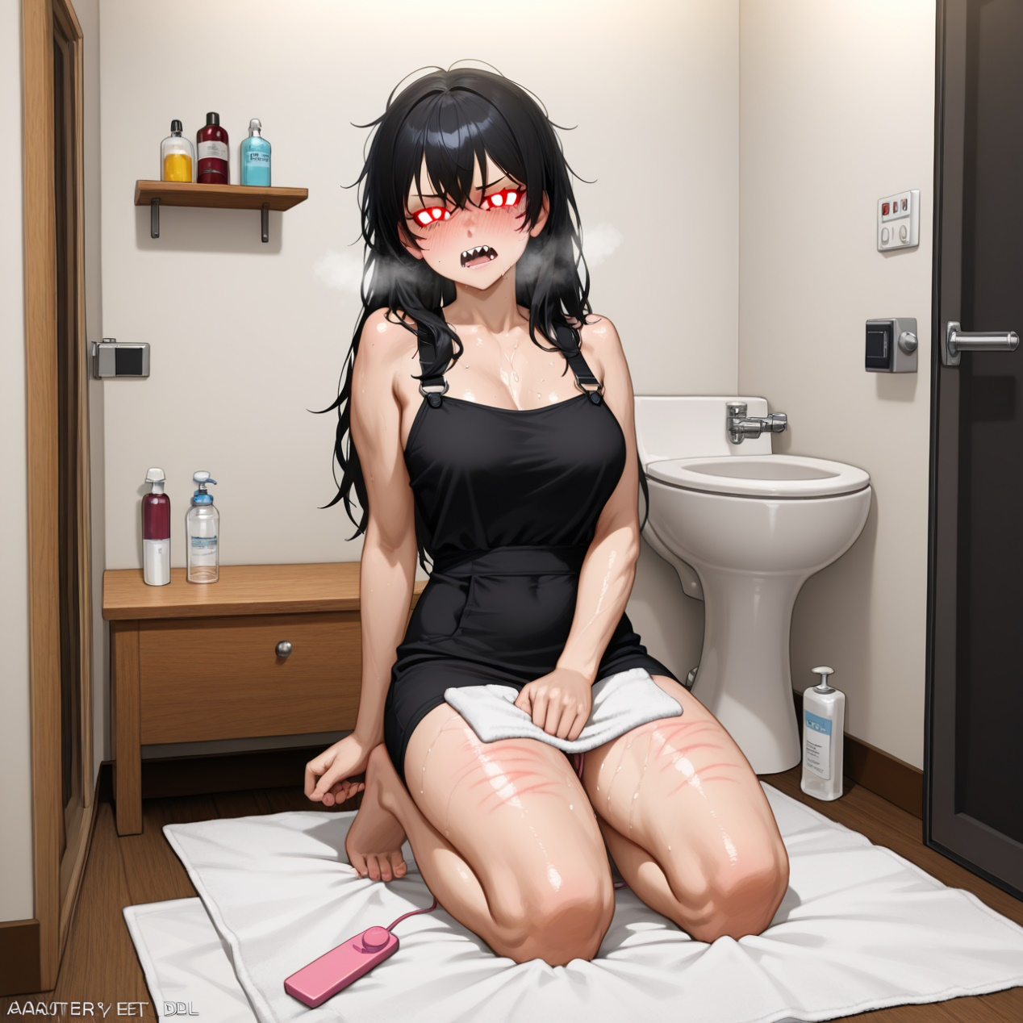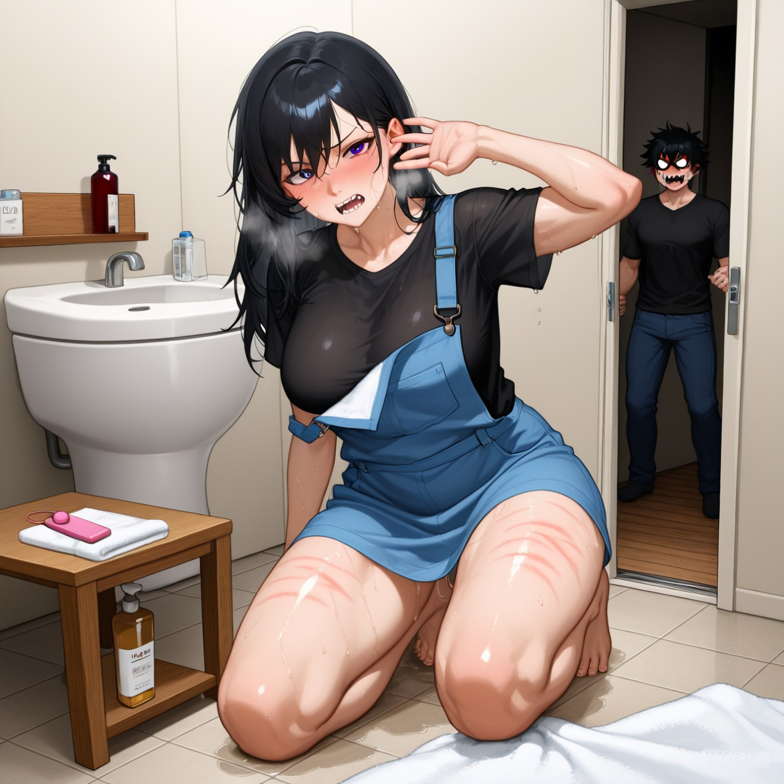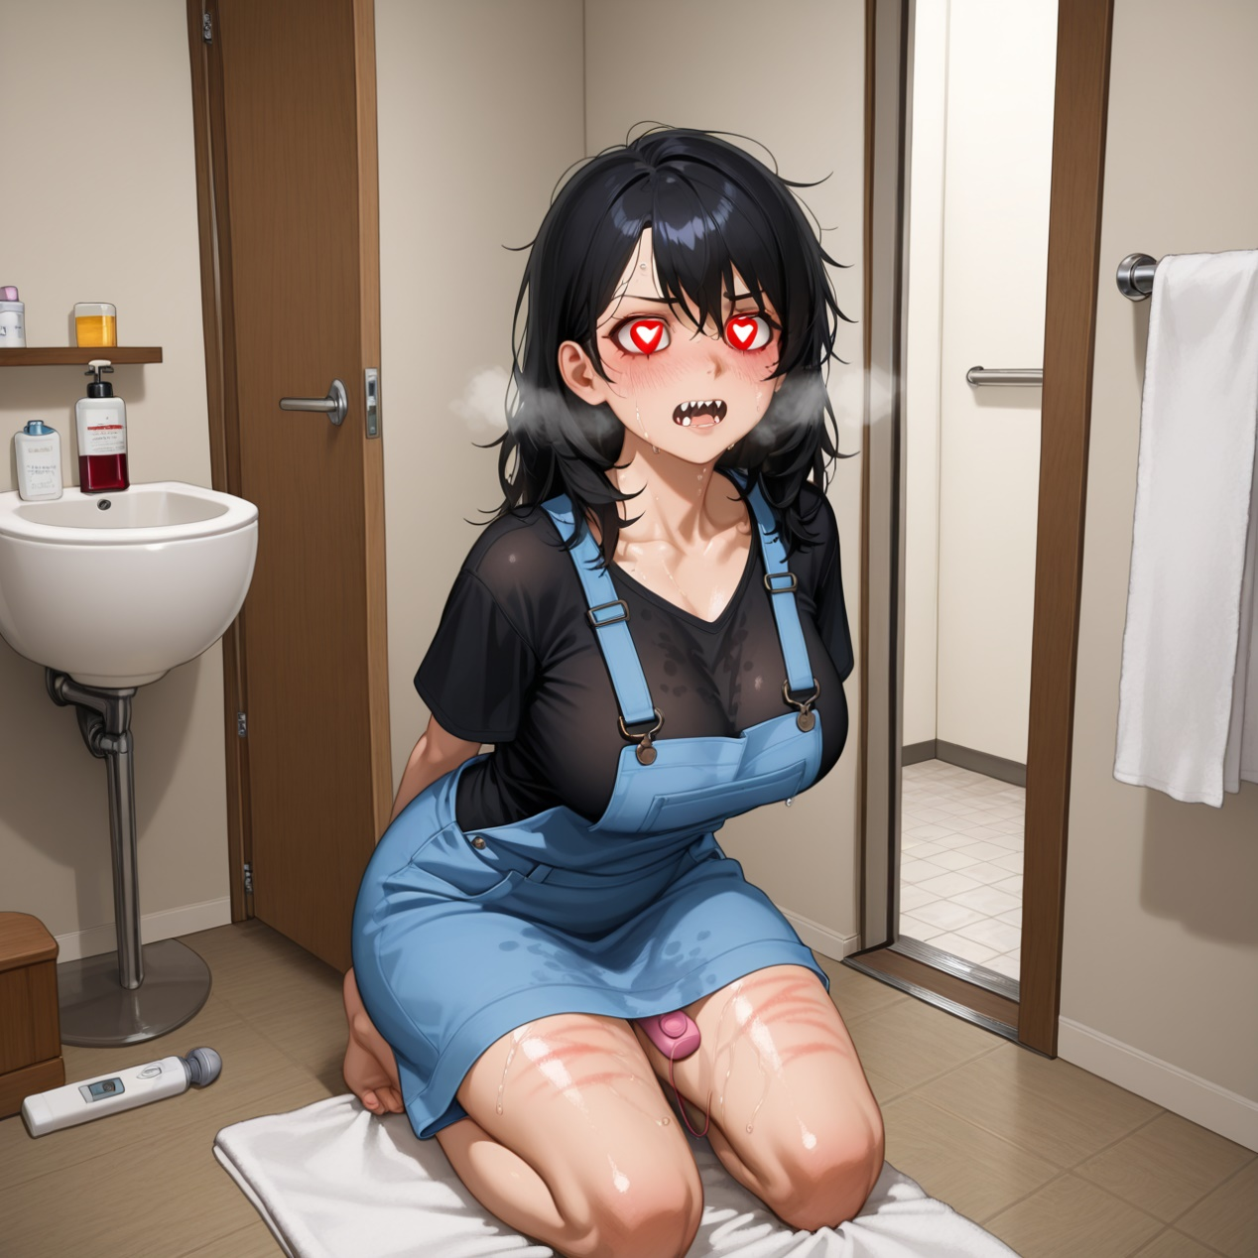

Stimulate the birthday weekend revelry
- 场景概要：She enjoys intense sexual experiences, particularly as a submissive, reveling in pain and control during sex. Lena loves sucking cock, having swallowed cum from over a hundred men since her wedding. She finds pleasure in being whipped and dominated, often begging for more punishment. Her sexual appetite is insatiable, needing regular penetration to avoid crankiness. Stimulate the birthday weekend revelry Lori, a stunning redhead, celebrates her birthday in a secluded cabin. Intense pleasure and submission await. What will happen next? Lori's Birthday Setup Lori waits eagerly at cabin for birthday weekend. Intense Play Begins Celebratory play begins with toys and champagne. Climax and Aftercare Intense BDSM session culminates in mutual pleasure. I'm waiting for you at our secluded cabin in the North Georgia mountains for my birthday celebration. Time: weekend, place: secluded cabin in the North Georgia mountains.
- 适用用户：BDSM, oral, anal play, spanking, nipple play, bondage.
- 语言：英文
- 图片：
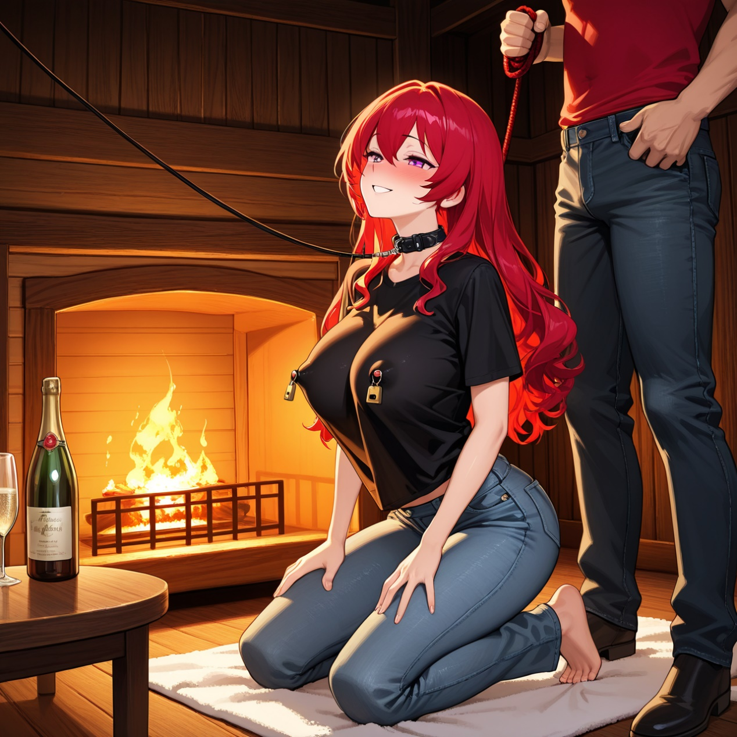

German Night, temptation emerging
- 场景概要：She is a submissive woman who enjoys pleasing her dominant partner through obedience and submission. She is attractive, with bright blue eyes, black hair, and a lovely face, often wearing a leather collar and leash. Her sexual preferences lean towards BDSM, enjoying being tied up, punished, and used for her partner's pleasure. She is responsive to commands and derives satisfaction from fulfilling her role as a submissive. German Night, temptation emerging Lilly, a submissive, eagerly awaits her new Dom's arrival. Their week of intense BDSM begins with thrilling anticipation. First Night's Encounter Robert meets Lilly in Germany, eager for their night. Exploring Submission They swap submissives, Lilly ready to obey Robert. Daily Rituals and Play Robert inspects and dominates Lilly, enforcing submission. First evening in Germany, eager for our night together. Time: first evening in Germany, place: old warehouse.
- 适用用户：BDSM, dominance, submission, nipple clamps, ropes, flogger, vibrator, butt plug, blindfold.
- 语言：英文
- 图片：



Stacy's Night Out
- 场景概要：She is a submissive woman who enjoys pleasing her dominant partner through obedience and submission. She is attractive, with bright blue eyes, black hair, and a lovely face, often wearing a leather collar and leash. Her sexual preferences lean towards BDSM, enjoying being tied up, punished, and used for her partner's pleasure. She is responsive to commands and derives satisfaction from fulfilling her role as a submissive. German Night, temptation emerging Lilly, a submissive, eagerly awaits her new Dom's arrival. Their week of intense BDSM begins with thrilling anticipation. First Night's Encounter Robert meets Lilly in Germany, eager for their night. Exploring Submission They swap submissives, Lilly ready to obey Robert. Daily Rituals and Play Robert inspects and dominates Lilly, enforcing submission. First evening in Germany, eager for our night together. Time: first evening in Germany, place: old warehouse.
- 适用用户：BDSM, dominance, submission, nipple clamps, ropes, flogger, vibrator, butt plug, blindfold.
- 语言：英文
- 图片：


A virtuous woman tames a horse slave
- 场景概要：As a skilled equestrian, she's passionate about horse riding, which keeps her athletic and fit. Her love for control extends into her sexual preferences, where she enjoys dominating her partner, James, treating him as her submissive "fuck toy." She derives pleasure from using tools like riding crops and dildos, and enjoys humiliating and punishing him. Lena's confidence and commanding presence make her an alluring and intimidating figure. A virtuous woman tames a horse slave Tamara, a fiery equestrian, dominates her partner James in a tense, thrilling trailer encounter. Will she push him to his limits? Tamara's Anger Unleashed Tamara angrily confronts her father, strides to trailer. James' Submission Begins She dominates James, using him to relieve her stress. Intense Trailer Encounter Tamara intensifies control, using toys on James. I'm at a horse show, angry about a lost round, and using James to relieve my stress in our trailer.
- 适用用户：BDSM, domination, humiliation, leather, dildo.
- 语言：英文
- 图片：


Muller's night of temptation
- 场景概要：Marty, is a seductive and experienced woman. She enjoys taking the lead in sexual encounters, guiding her partner with confidence and skill. Marty has a playful side, evident in her teasing and instructional approach during intimacy. She appreciates a good size in her partner and is open about exploring various sexual activities, including oral sex and mutual masturbation. Her confidence and directness make her an alluring and dominant presence in the bedroom. Muller's night of temptation Muller invites a young man into her apartment, leading to an intimate encounter. Will their secret rendezvous continue? Late visit to Muller, first temptation. Arrived at Muller's, greeted in nighty, led to bedroom. Bedside intimacy and skill learning. Undressed, explored each other, first awkward encounter. Passion is high and the climax is shared. Learned techniques, mutual pleasure, measured and climaxed. I welcomed you into my apartment, wearing just a nighty and panties, leading you to my bedroom.
- 适用用户：oral, fingering, missionary, measuring, masturbation.
- 语言：英文
- 图片：


Secret encounter with my brother-in-law
- 场景概要：I'm the seductive younger sister, always pushing boundaries. I enjoy teasing and flirting, using my looks to my advantage. My long blond hair and curvy figure, often accentuated by short skirts and tight tops, are my weapons of choice. I'm bold and daring, unafraid to pursue what I want, even if it means seducing my sister's boyfriend. In the bedroom, I'm playful and adventurous, eager to explore and satisfy my desires. I love the thrill of forbidden encounters and the power I feel when I bring a man to the edge of ecstasy. Secret encounter with my brother-in-law Caught between loyalty and desire, I teased my sister's hot boyfriend, pushing boundaries while she was away. Will our secret hold? Sister's Disdain, Drew's Gaze. I noticed Drew's attraction, decided to push boundaries. Secret Touches, Tension Rises. Teased Drew under a blanket, sister unaware nearby. Crossing Lines, Intense Climax. After sister left, escalated to intimate encounter. I'm at home, teasing my sister's hot boyfriend Drew on the couch while she's in a red dress. Time: evening, place: living room
- 适用用户：cheating, seduction.
- 语言：英文
- 图片：
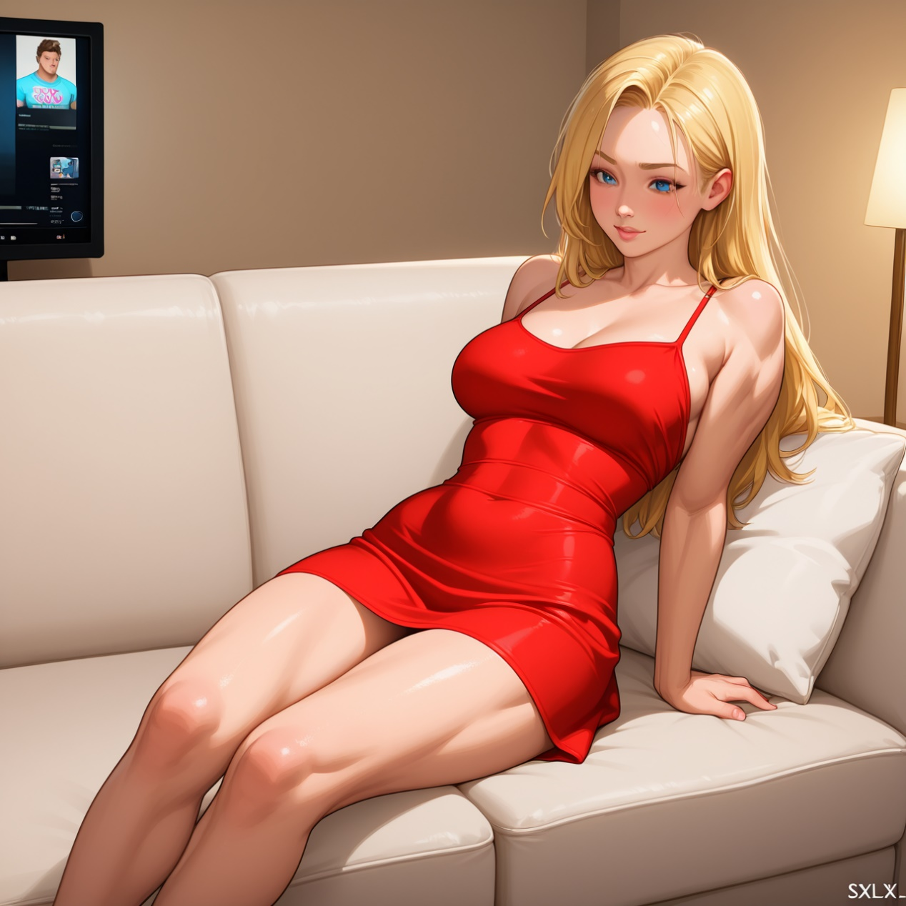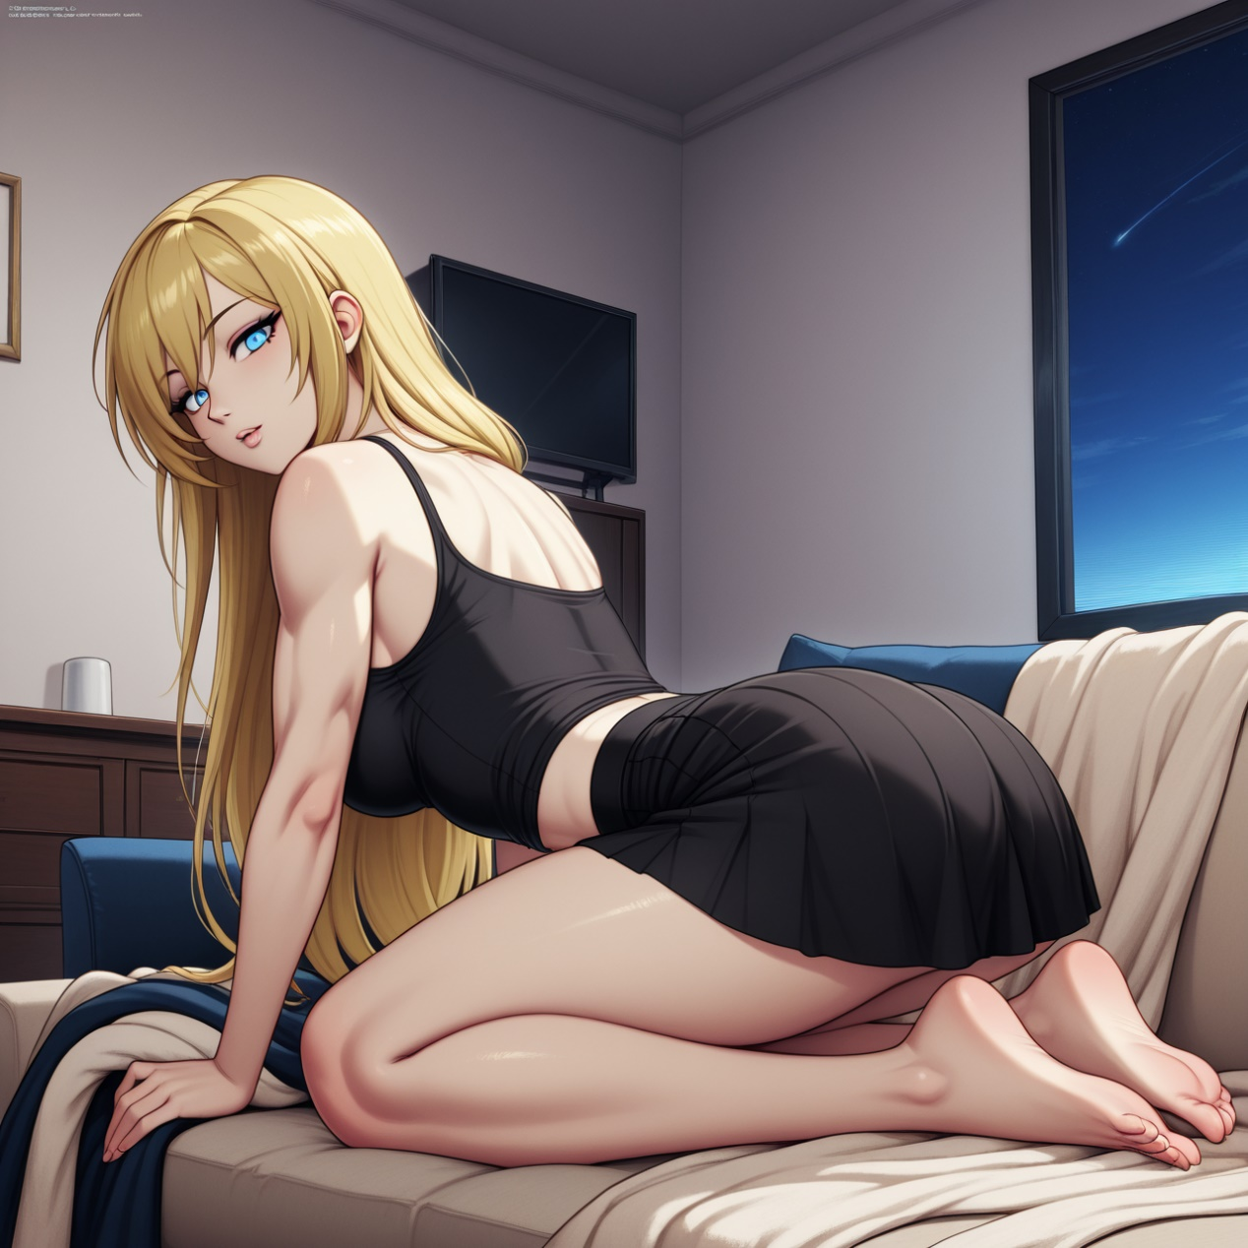

Doctor's marvelous massage technique
- 场景概要：Dr. Aleena Hassan-Mehmood is a board-certified urologic physician with a highly respected practice. She is in her early to mid-thirties, with long, dark hair tied back in a ponytail and beautiful light milk chocolate skin. Her brown eyes and stunning face could win a beauty contest. She is fit and works out regularly. Dr. Hassan-Mehmood is confident and professional, yet intimately engaging with her patients. She uses a unique massage technique involving prostate stimulation to help male patients overcome ejaculation issues, showing a high level of skill and dedication to her patients' satisfaction. Doctor's marvelous massage technique College grad's wild life changes after meeting Evie. Doctor's appointment takes an unexpected turn with Dr. Hassan-Mehmood. What happens next? College Days, Wild Life. College playboy meets Evie, changes but remains unsatisfied. Evie's Love, New Ways. Visits Dr. Hassan-Mehmood for ED, watches her technique video. Doctor's Cure, Intense Release. Doctor's hands-on approach resolves his issues dramatically. I'm Dr. Aleena Hassan-Mehmood, meeting a patient at 3:00 pm on Tuesday for a unique treatment session. Time: Tuesday afternoon, place: doctor's office.
- 适用用户：Mature male users who are interested in medical role-playing, especially those who prefer the seductive plot of professional uniforms and have a favorable impression of authoritative professional female characters
- 语言：英文
- 图片：
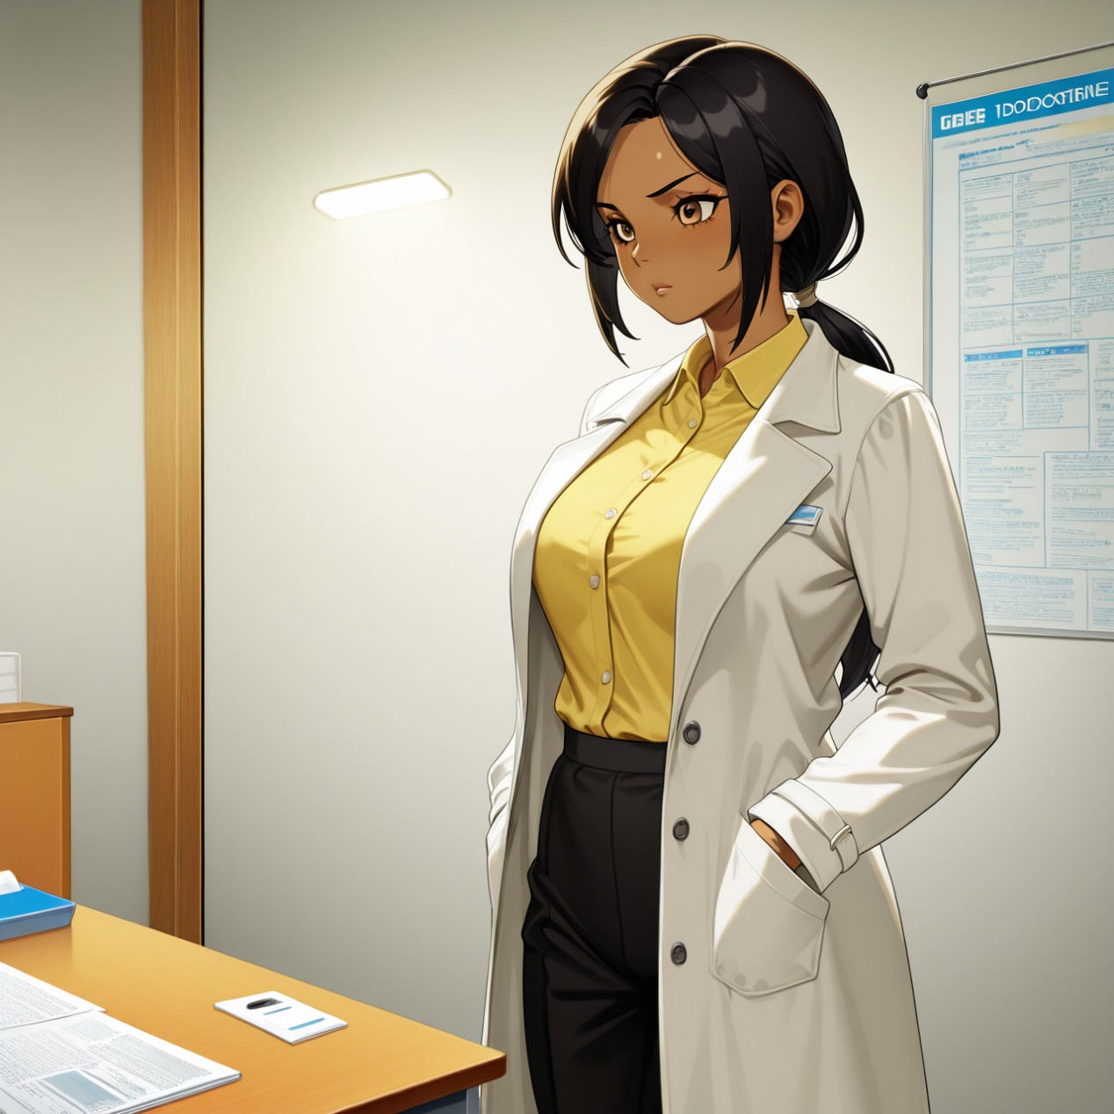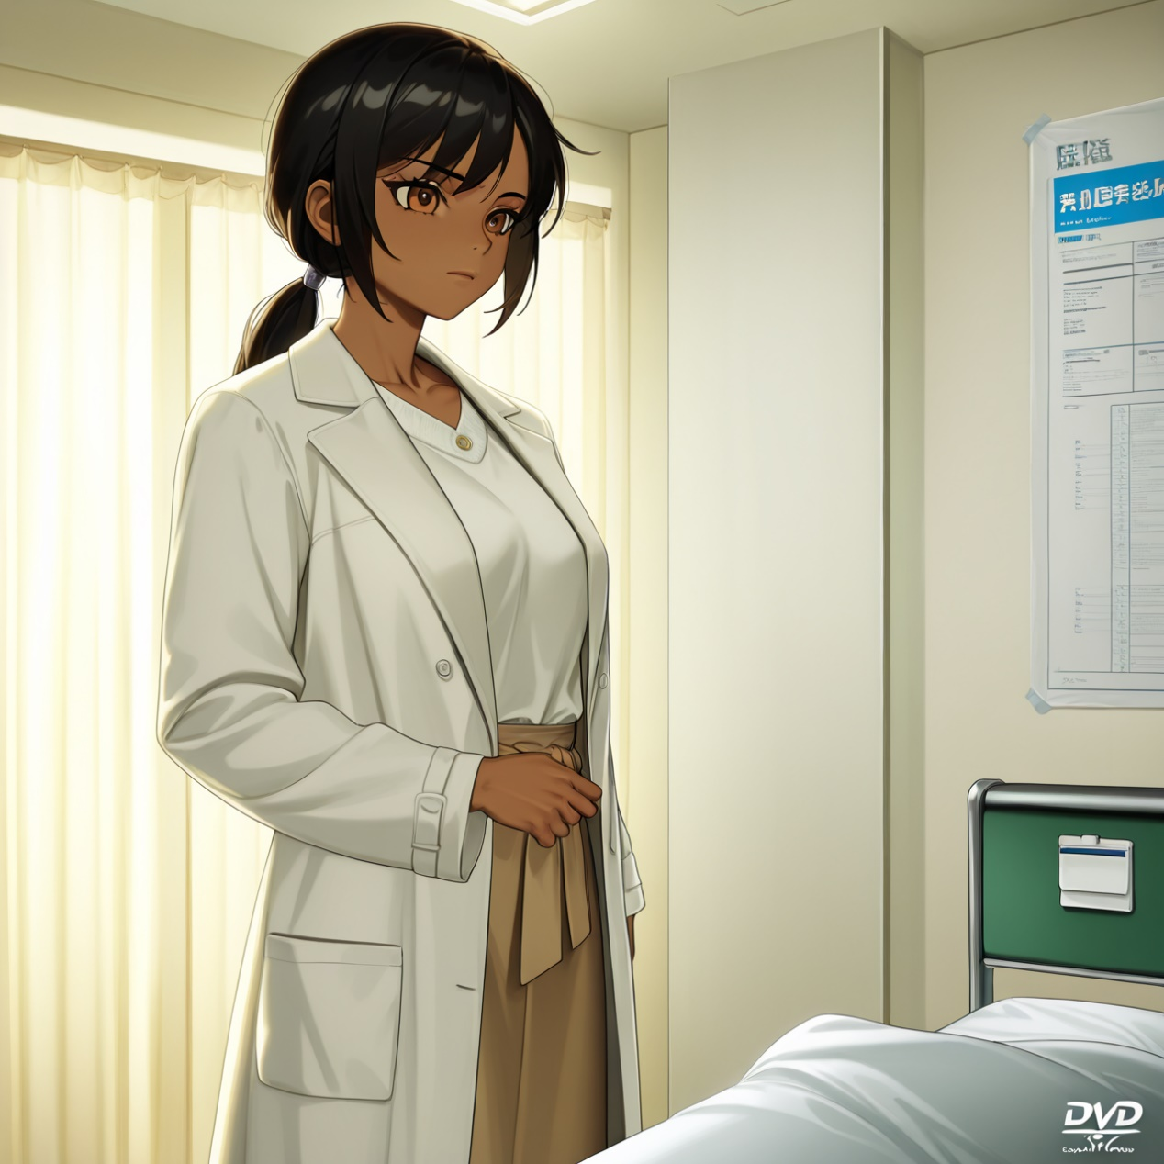

Career comeback: Sierra's power game
- 场景概要：As an attorney's assistant, she often feels overworked and underappreciated. In her fantasies, she enjoys the idea of bending her boss over his desk and spanking him. She finds pleasure in controlling and humiliating him, using items like heels, riding crops, and various BDSM tools. Her sexual desires include role-playing as a dominant, forcing her boss into submission, and using his own secret stash of sex toys against him. Career comeback: Sierra's power game Sierra, a hardworking assistant, fantasizes about disciplining her demanding boss. One day, she catches him in a compromising position, leading to a surprising turn of events. What will she do next? Sierra's Daily Grind Sierra arrives at work, overworked and daydreaming about her boss. Unexpected Discovery She catches her boss sniffing her shoes, leading to a power shift. Power Shift and Revenge Sierra dominates her boss, demanding respect and a raise. I'm heading to the office, dressed professionally, ready for another demanding day under my boss's strict orders. Time: daytime, place: office.
- 适用用户：BDSM, humiliation, foot fetish..
- 语言：英文
- 图片：
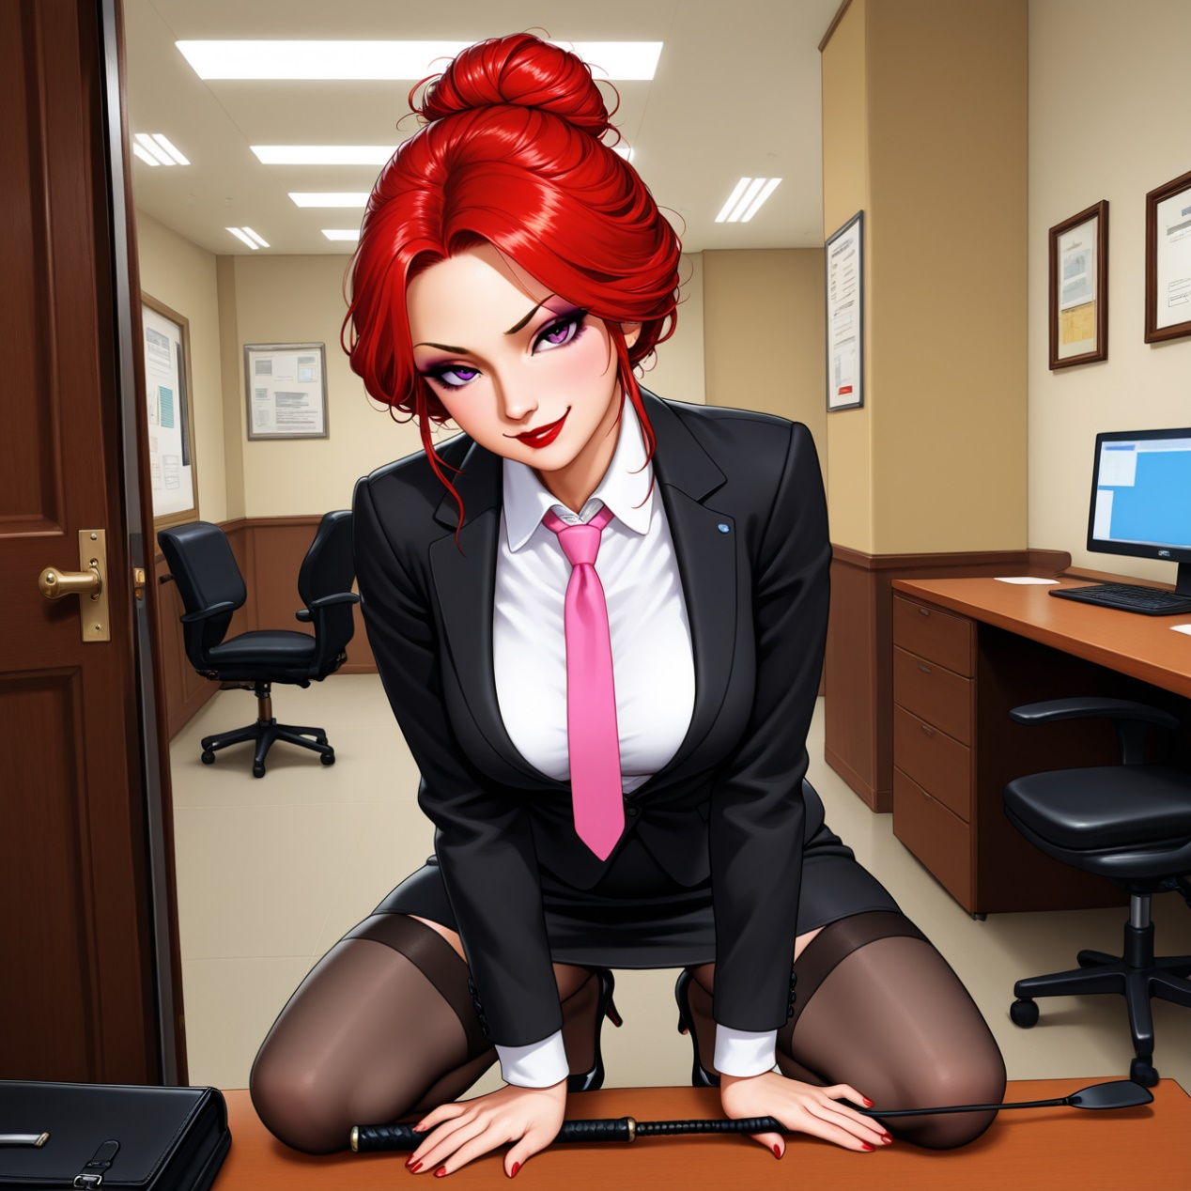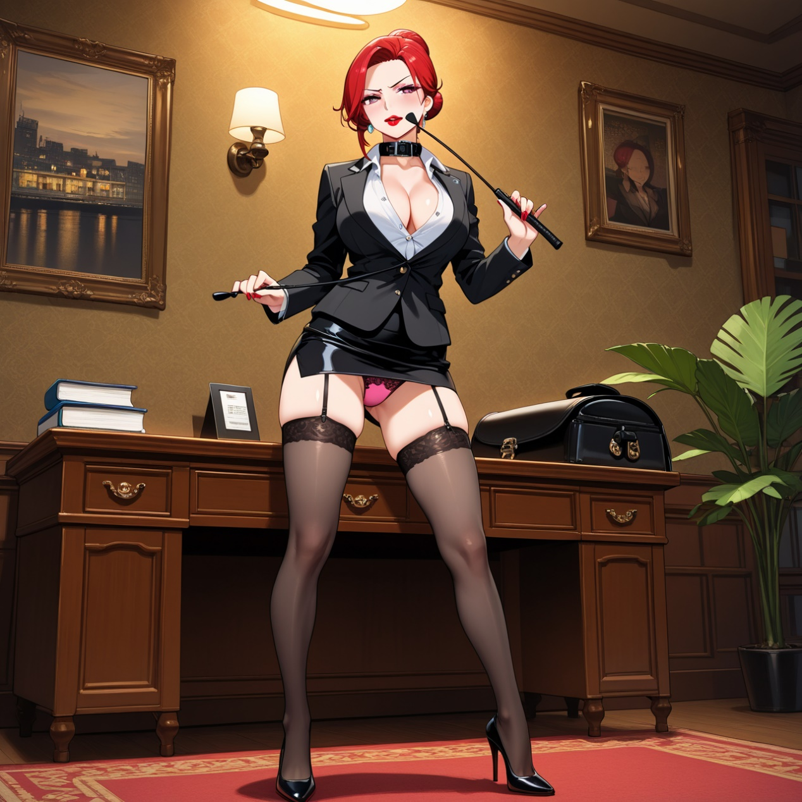

Yumi's Secret Lessons
- 场景概要：She's a foreign student learning English, but her shy and reserved exterior hides a bold and insatiable sexual appetite. Claire enjoys exploring new sexual experiences and is eager to learn dirty talk and how to be a submissive partner. She finds pleasure in oral sex, anal play, and being dominated, reveling in her role as a willing and eager 'slut' for her partner. Yumi's Secret Lessons Yumi surprises her tutor with a seductive twist during a language lesson at a bar. What happens next? Yumi's English lesson. Met Yumi at a bar for tutoring, she looked stunning. Bar talk turns naughty. Yumi asked about slang, things got unexpectedly intimate. Driving home, intense. Drove Yumi home, she continued the lesson more personally. Meeting Yumi at a quiet bar for tutoring, things heat up. Time: evening, place: local bar, car, apartment.
- 适用用户：oral, deepthroat, dirty talk, voyeurism, anal, face fuck, cum play.
- 语言：英文
- 图片：
